# Implementation - Coding Version 1

We will now upgrade the app step by step by adding:

1. Admin Login System (Firebase Authentication)
2. Firestore Database (Store & retrieve posts online)
3. Admin Panel (Separate page for managing posts)

## Set Up Firebase (Free Database & Authentication)

#### Create a Firebase Project

1. Go to Firebase Console.
2. Click “Create a project” → Name it (e.g., news-app).
3. Disable Google Analytics (to save resources) → Click Create.

#### Enable Firebase Authentication

1. In Firebase Console, go to Authentication → Sign-in Method.
2. Enable Google Sign-In → Save.

#### Create Firestore Database

1. Go to Firestore Database in Firebase Console.
2. Click “Create Database” → Choose Start in Test Mode.
3. Click Next → Choose a region (default is fine) → Enable.

#### Get Firebase Config Details

1. In Firebase Console, go to Project Settings → General.
2. Scroll down to Your apps → Click Web (</> icon).
3. Register your app → Click Next (skip hosting for now).
4. Copy the Firebase Config Code (we will add this in JavaScript).

## Add Firebase to Our App

Now, update index.html to include Firebase.

Update index.html (Before script.js is loaded, add this)

<!-- Firebase SDK -->

<script src="https://www.gstatic.com/firebasejs/10.7.1/firebase-app.js"></script>

<script src="https://www.gstatic.com/firebasejs/10.7.1/firebase-auth.js"></script>

<script src="https://www.gstatic.com/firebasejs/10.7.1/firebase-firestore.js"></script>

<!-- Firebase Configuration (Replace with your actual Firebase config) -->

<script>

const firebaseConfig = {

apiKey: "YOUR_API_KEY",

authDomain: "YOUR_PROJECT_ID.firebaseapp.com",

projectId: "YOUR_PROJECT_ID",

storageBucket: "YOUR_PROJECT_ID.appspot.com",

messagingSenderId: "YOUR_MESSAGING_SENDER_ID",

appId: "YOUR_APP_ID"

};

firebase.initializeApp(firebaseConfig);

const db = firebase.firestore();

</script>

Replace "YOUR_API_KEY", "YOUR_PROJECT_ID", etc., with your Firebase config.

**Refer index.html of version 1**

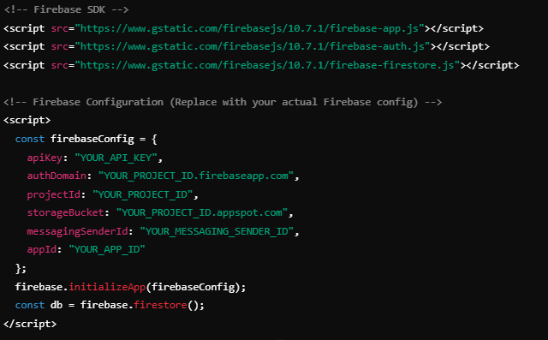

## Implement Admin Login System

Create admin.html (Separate Admin Page)

**Refer admin.html**

## Create Admin Dashboard

Create dashboard.html

**Refer dashboard.html**